SOLDERING NOTES

- Heat the iron, keep the tip tinned; wipe on the damp sponge only before
using. This will help heat transfer to your work.
- To avoid damage to the cord, and yourself and others keep the iron in your hand or in the stand.
- Do not remove excess solder from the iron before placing the iron in the stand or turning off

PREPARING COMPONENTS AND LEADS

Most new components have plated or pre-tinned leads that will accept solder without any special preparation. However, if the components are old, with the leads dirty or tarnished, they should be cleaned and tinned before attempting to solder them into position. The best way to clean the leads is to use an in eraser, rub the leads gently but firmly.

TO SOLDER A CONNECTION

- Place the soldering iron tip against both the lead and the circuit board foil. Heat both for at least two or three seconds.
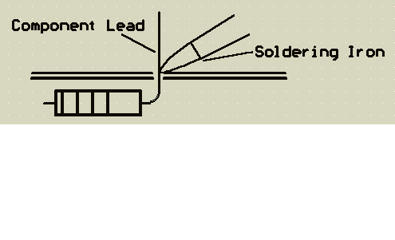

- A small amount of solder may be placed on the soldering iron tip to improve heat transfer to the lead and the foil. Then apply solder to the other side of the connection.
IMPORTANT: Let the heated lead and the circuit board foil melt the solder.
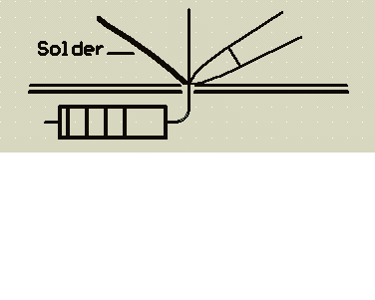

- As the solder begins to melt, allow it to flow around the connection. Then remove the solder and the iron at the same time and let the connection cool.
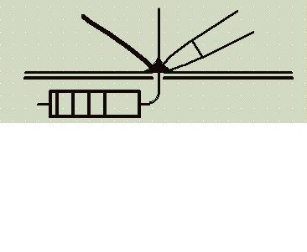

SOLDERING INFORMATION

The solder used in Electronics is called resin-cored solder. It has five hollow tubes throughout its length, filled with flux.

When the solder is melted, the flux runs out and helps to clean the work that you are soldering.

The solder should melt as a result of touching the heated wire, PCB foil etc. Not by touching the iron only.

Tinning is the process of placing a thin coating of solder over metal. Tinning is needed on the soldering iron tip an on parts to be soldered together.

Poor soldering jobs are the cause of many models not working, or not working properly. Usually the look of the soldering job will indicate if the soldering is satisfactory.

Poor soldering has a crystalline or grainy look. It is often in blobs and appears dry.

Good soldering is smooth and even; it tapers at the edges. It is bright and shiny in appearance and has a “wet” look.

QUESTIONS: - Write in sentence form the answers to the following questions.

- Why is flux used?

- What might happen because of poor soldering?

- How does a good soldering job look?

- How does a poor soldering job look?

- What is tinning?

- What should actually melt the solder onto the wire, foil etc.?

- Why should the soldering iron tip be cleaned?

- What should be done to take care of the soldering iron cord?

- What type of solder is used in electronics?

- What side of the connection should the solder be applied to?

